**Program Title : Gas Sensor**

**Aim : Design a smart gas leakage indicator system.**

**Hardware Required :**

* Arduino Board
* Gas sensor
* LED

**Circuit Diagram :**

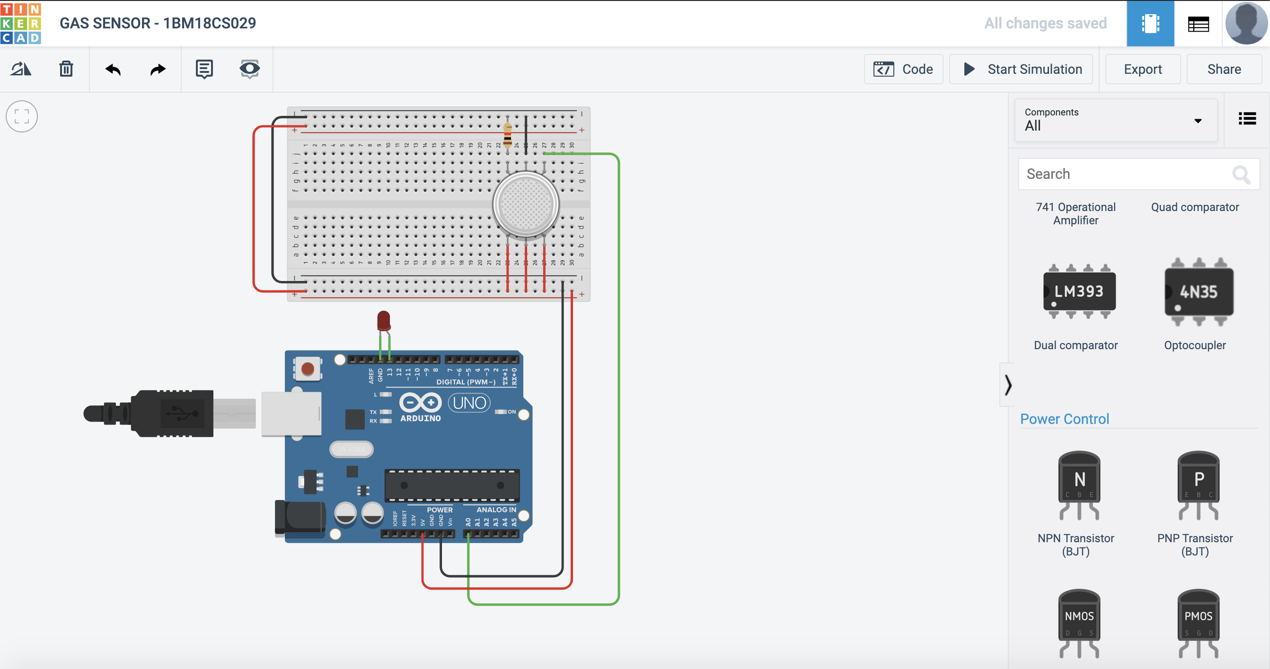

**Output/Working :**

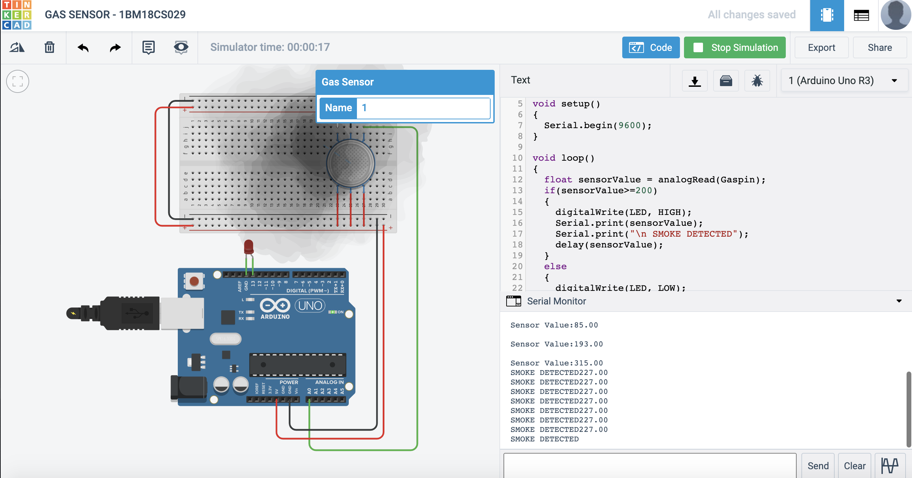

**Code:**

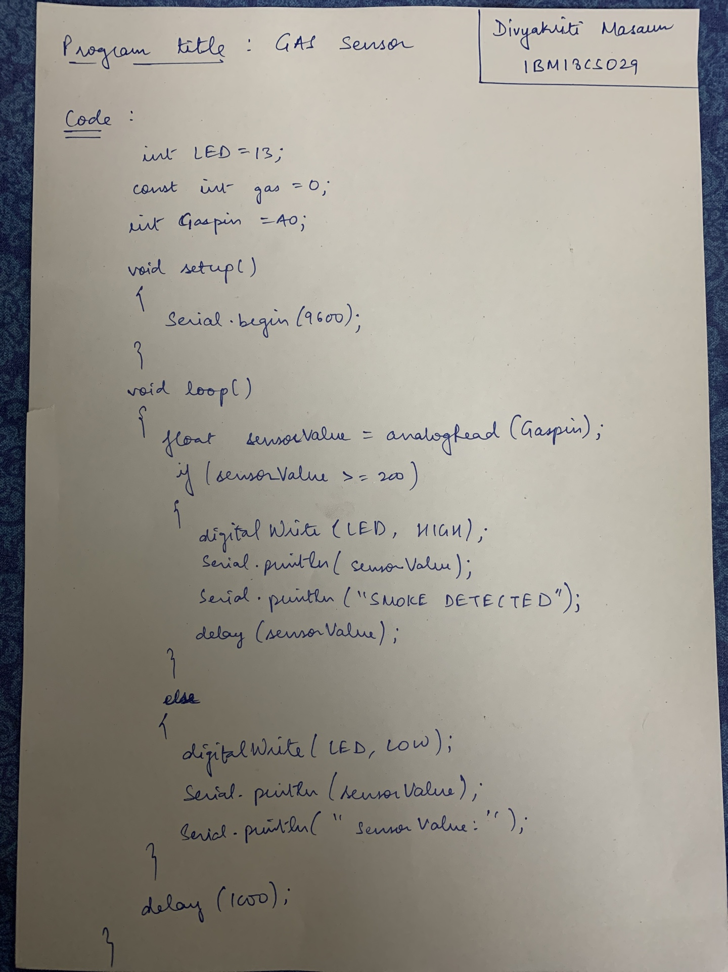

**Observation :**

When the gas sensor senses the smoke, LED glows otherwise LED will be in LOW state and wont glow.